# Expert Month-End Application User Guide

## Overview

### 1.1.1 About Expert

Expert is a leading company based in South Africa, specializing in facilitating seamless transactions between dealers and vendors. With a commitment to efficiency and transparency, Expert serves as the trusted intermediary, streamlining the business processes involved in these transactions.

### 1.1.2 Business Processes

In the dynamic landscape of business transactions, Expert plays a pivotal role as the intermediary connecting dealers and vendors. The core business process involves the capturing of transactions between the dealer and the vendor, with Expert acting as the central hub for communication and coordination.

**Key business processes:**

1. **Transaction Capture:**

The “Month End” application is designed to capture transactions between the dealer and the vendor. This ensures accurate and timely recording of all financial interactions.

1. **Middle-Man Facilitation:**

Expert serves as the middle man in the transactional process, facilitation communication and collaboration between the dealer and the vendor. This role enhances efficiency and reduces potential communication gaps.

1. **Remittance Procedures:**

* **Dealers to Expert:**

The application provides a streamlined process for capturing remittances from dealers to Expert. This ensures transparent and traceable financial transactions, contributing to the overall efficiency of the payment process.

* **Expert to Vendors:**

Additionally, the “Month End” application facilitates the remittance process from Expert to vendors. This feature allows for seamless financial transactions between Expert and vendors, contributing to a transparent and accountable financial ecosystem.

### 1.1.3 Importance of the “Month End” Application

The primary purpose of the “Month End” application is to enhance the efficiency of financial processes, specifically focusing on transactions between dealers and vendors. This guide will walk you through the installation, setup, and utilization of the application, ensuring that you can leverage its features to streamline month-end activities.

### 1.2 System Requirements

Before you begin using the “Month End” application, please ensure that your system meets the following requirements:

* **Operating System:** Windows 7 or later.
* **Processor:** Intel Core i5 or equivalent.
* **RAM:** 4GB
* **Disk Space:** 10GB

### 1.3 How to use this guide:

This user guide is structured to guide you through the entire process of using the “Month End” application. Please follow the sections in order to get the most out of the guide:

1. **Introduction:** Youa re currently reading the introduction, which provides you with an overview of the application.
2. **Getting Started:** Learn how to install and set up the “Month End” Application’s user interface.
3. **User Interface:** Familiarize yourself with the key elements of the application’s user interface.
4. **Main Features:** Explore detailed instructions on using each major feature of the application.
5. **Advanced Functionality:** If you are an advanced user, find instructions for more intricate tasks.
6. **Troubleshooting:** Discover solutions to common issues and error messages.
7. **FAQs:** Review frequently asked questions for quick answers.
8. **Support:** Find contact information for customer support and additional resources

Now, let’s get started with the installation and setup of the “Month End” application!

## 2. Getting Started

### Installation Instructions:

1. After receiving the complete zip folder from a trusted employee or administrator. Right click on the compressed folder. You will be prompted with the following:

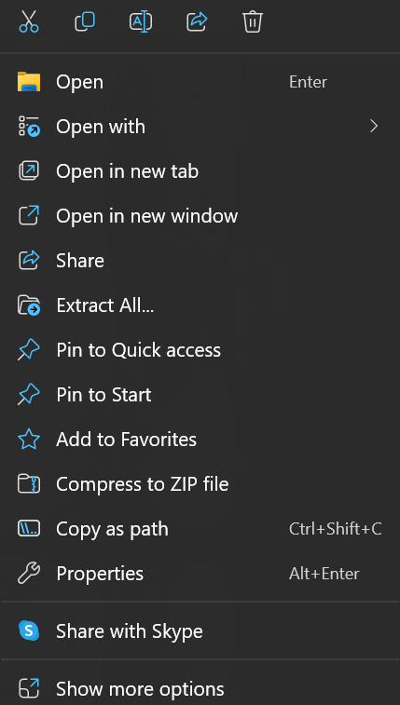

1. A screenshot of a computer

   Description automatically generatedSelect the “Extract All” options. Thereafter you will be prompted with the following window:

1. Choose a destination of your choice where you want to install the application and click on the “Extract” button.
2. After the extraction of the folder completed, double click on the “MonthEnd” folder. You will thereafter see different files of the application showed in the following snapshot:

1. Double click on the ISERMonthend.exe file. (If prompted with the following screen, click on the “More info” link.)

1. Choose the “Run anyway option”.

1. After selecting “Run Anyway” you will be prompted with the following screen:

1. Use the credentials provided to you from an Expert Administrator or staff member to sign into the system.

Please note: If you are prompted with the following screen, your public IP was not registered on the system and assistance needs to be provided from system administrators to assign you to the system to gain access.

